**Department of Electrical and Computer Engineering**

**North South University**



**CSE445 Report**

**Sleep Disorder Prediction System Using Machine Learning**

**Readuanul Farid Fahim ID : 202174862**

**Md. Harun Or Rashid ID: 2021254642**

**Masum Musfiq ID:2013334042**

**Nasid Ahmed Chowdhury ID:2012816042**

**Mithila Sutradhar ID :2021988042**

**Group: 05**

**Faculty:**

**Riasat Khan**

**Assistant Professor**

**ECE Department**

**Spring, 2024**

**Individual Contribution Table**

|  |  |  |
| --- | --- | --- |
| **Section** | **Contributing Member Name** |  |
| IEEE/LaTEX formatting | Readuanul Farid Fahim |  |
| Grammarly check | Readuanul Farid Fahim | 98% |
| Abstract | Masum Musfiq |  |
| Keywords | Mithila Sutradhar |  |
| Introduction Motivation | Md. Harun Or Rashid |  |
| Paper Review 1 | Md. Harun Or Rashid |  |
| Paper Review 2 | Nasid Ahmed Chowdhury |  |
| Paper Review 3 | Mithila Sutradhar |  |
| Paper Review 4 | Readuanul Farid Fahim |  |
| Paper Review 5 | Masum Musfiq |  |
| Introduction Second-Last Paragraph | Md. Harun Or Rashid |  |
| Proposed System (Dataset and Preprocessing) | Mithila Sutradhar |  |
| Proposed System (Model description) | Decision tree | Mithila Sutradhar |
| KNN | Nasid Ahmed Chowdhury |
| SVM | Nasid Ahmed Chowdhury |
| Random Forest | Md. Harun Or Rashid |
| Bagging | Md. Harun Or Rashid |
| Logistic Regression | Readuanul Farid Fahim |
| AdaBoost | Masum Musfiq |
| XGBoost | Masum Musfiq |
| GradBoost | Masum Musfiq |
| Results and Discussion | Nasid Ahmed Chowdhury |  |
| Figure and Table Title Formatting | Nasid Ahmed Chowdhury |  |
| Conclusions | Masum Musfiq |  |
| References Formatting in IEEE format | Readuanul Farid Fahim |  |

**Sleep Disorder Prediction System Using Machine Learning**

Readuanul Farid Fahim   
Electrical and Computer Engineering  
North South UniversityDhaka, Bangladesh  
readuanul.farid@northsouth.edu

Masum Musfiq  
Electrical and Computer Engineering  
North South UniversityDhaka, Bangladesh  
masum.musfiq@northsouth.edu Md. Harun or Rashid  
Electrical and Computer Engineering  
North South UniversityDhaka, Bangladesh  
harun.rashid01@northsouth.edu

Mithila Sutradhar  
Electrical and Computer Engineering  
North South UniversityDhaka, Bangladesh  
mithila.sutradhar@northsouth.edu Nasid Ahmed Chowdhury  
Electrical and Computer Engineering  
North South UniversityDhaka, Bangladesh  
nasid.ahmed@northsouth.edu

*Abstract*— Sleep disorders are the disturbance of our regular sleep pattern, which injure an individual's health and quality of life. This project uses machine-learning techniques to predict whether a person sleeps regularly or suffers from sleep apnea or insomnia. As modern science advances, AI leaves a potential mark as a powerful tool in the medical industry since it contains patients' information and can improve patients' diagnostic capacities in the guidance of sleep disorders. The project involved various machine learning algorithms on a dataset containing valuable patient information to construct predictive models for categorizing sleep disorders. In this project, Bagging got the best accuracy of 92%, the highest compared to other models.

***Keywords—Machine Learning, Accuracy, Data Preprocessing, Hyperparameters, Evaluation Metrics, Classification***

# Introduction

Sleep is a fundamental physical condition for the human body and mind; our somatic, cognitive, and psychological processes depend on sleep. Sleeping disorder is a biological condition that interrupts sleep patterns, quality, and duration for millions worldwide. Medical conditions like heart disease, nerve conditions, depression, genetic factors, working night shift, caffeine, and alcohol are some of the known causes of sleeping disorders. There are more than 80 different types of sleeping disorders. Some of them are Insomnia, sleep apnea, restless legs syndrome, narcolepsy, etc. Some studies show that in the USA alone, 50 – 70 million people suffer from sleep disorders, and 10-15 % worldwide have chronic Insomnia. Sleeping disorders can be treated by sleeping pills, melatonin supplements, breathing devices, a healthy diet, maintaining a regular sleep schedule, reducing stress and anxiety, decreasing tobacco, alcohol, and caffeine use, etc. Polysomnography (a sleep study) records brain waves, oxygen levels, heart rates, and breathing during sleep and is used to diagnose sleeping disorders. We chose this project to help doctors identify precisely which kind of sleeping disorder a patient has. It will reduce a doctor's time to diagnose the patient for a sleeping disorder so that the doctor can focus on treatment immediately.

In [1], Soni et al. made a logistic regression version for measuring sleep disorder detection Accuracy. They used a sleep health and lifestyle dataset obtained from Kaggle, which had 374 rows and 13 columns with different characteristics that affect sleep, such as age, sex, occupation, sleeping time, sports activity, stress levels, and BMI categorization was also taken into account. This data set was divided into a training set with 70% of all cases, while the remaining ones serve as a checking pattern for our model. Opposed to models such as assist vector machines, decision trees, and k-nearest neighbors, the proposed gradient-boosting model was evaluated; however, afterward, the logistic regression achieved the highest Accuracy of 93.51% for the sleep disorder class.

Alshammari [2] classified sleeping disorders using different machine-learning algorithms. The author used a publicly available dataset from Kaggle named the sleep health and lifestyle dataset, which contains 400 rows and 13 columns with various features representing sleep and daily activities. Random forest, support vector machine, k-nearest neighbors, decision tree, and artificial neural network are the methods used to classify sleeping disorders. The algorithms used in this project obtained a classification accuracy of 91.15%, 92.04%, 83.19%, 88.50%, and 92.92%, respectively.

Payne et al. [3] observed a sleep disorder, which is a biological condition that interrupts the sleep pattern, duration, and quality of sleep. The target of this paper was to predict the probability of individuals who have Insomnia, sleep apnea, or having a regular sleep pattern. This process is beneficial for doctors to find out their patients' problems quickly. Multiple machine-learning algorithms were applied in this paper. For greater satisfaction, they also used the RandomSearchCV. Using many machine learning algorithms, they tried to analyze the sleep disorder problems.

Richardt Howard Wilkinson and Colleagues [4] tried to see Sleep stage and sleep disorder detection from multimodal sensors using Deep learning. They have selected the automatic recognition of sleep stages and disorders from multimodal sensory data (ECG, EEG, and EMG) for their analysis. They furthermore tested the MML-DMS on the PhysioNet CAP Sleep Database with VGG16 CNN systems as their measure accuracy. Reach a moderate classification accuracy of 94.34%; their F1 score is 0.92 in sleep stage detection (six stages), and the average classification accuracy is 99.09%, and for sleep disorder detection, the F1 score is 0.99. (eight disorders)

Yadav et al. [5] used machine learning models to identify sleep disorders with a dataset of 374 rows and 13 coluamns. The dataset contains information like gender, occupation, BMI, and sleep disorder classification. After applying dataset preprocessing and feature engineering techniques, the dataset was divided into two sets: training 75% and testing 25%. Machine learning classifiers like Logistic Regression, XGBoost, and Decision Tree were applied, and the Decision Tree achieved the highest accuracy of 93.5%. Here, Yadav et al.[1], used one hot encoding to convert categorical data into numerical data, and a confusion matrix heat map plot helped visualize actual positive false positive values.

In this project, we used multiple machine-learning models to predict sleep disorders. A public dataset has been used in this project. We used a total of 9 machine-learning models in this project. Then, we used Accuracy, precision, recall, and F1 score values for evaluation metrics. Out of all the models, Bagging and Logistic regression gave us the best results.

Sleep disorders have become a widespread issue affecting people globally. Accurate and timely diagnosis is essential for effective treatment. Regular methods usually take too much time and require proficiency in particular areas. Automatic sleep disorder prediction systems are suggested in this work, which uses machine learning models for diagnosis simplification. In managing sleep disorders through more efficient procedures, quick and dependable predictions are targeted in such a system that operates on a data-driven basis.

# Proposed System

This section describes the theory of the software components/algorithms used in our project.

Algorithms and Software Elements Gathering and preprocessing data:

Pandas: To analyze and manipulate data.

NumPy: For manipulating arrays and performing numerical computations.

Scikit-Learn: For model training, evaluation, and preprocessing, use Scikit-Learn.

SciPy: For statistical functions (such as identifying outliers).

Oversampling strategies to deal with imbalanced datasets: Imbalanced-learn (SMOTE).

Matplotlib and Seaborn: for visualizing data.

1. **Dataset**:

A dataset is a collection of data that has been organized so that a person may use it to work toward their objectives. In essence, a dataset serves as the foundation for all operations, methods, and models. Thus, the data in our dataset includes details about people's sleep habits, levels of physical activity, and health indicators. This multiclass problem has 12 characteristics (columns) and 374 samples/instances.

**Features Description:**

Table I describes each feature in the dataset, including a brief description, unit, and minimum, maximum, and mean:

TABLE I. FEATURES DESCRIPTION OF THE USED DATASET

|  |  |  |  |  |  |
| --- | --- | --- | --- | --- | --- |
| **Feature** | **Description** | **Unit** | **Minimum** | **Maximum** | **Mean** |
| Person ID | Unique identifier for each specific one | - | 1 | 5 | - |
| Gender | Gender of the specific one. | - | - | - | - |
| Age | Age of the specific one. | Years | 27 | 28 | 27.8 |
| Occupation | Job title of the specific one. | - | - | - | - |
| Sleep Duration | Average sleep duration per night | Hours | 5.9 | 6.2 | 6.06 |
| Quality Of Sleep | Self-reported quality of sleep on a scale of 1 to 10 | Scale (1-10) | 4 | 6 | 5.2 |
| Physical Activities | Steps per day | Minutes | 30 | 60 | 48.4 |
| Stress Level | Self-reported stress level on a scale of 1 to 10. | Scale (1-10) | 6 | 8 | 7.4 |
| BMI Category | Body Mass Index category | - | - | - | - |
| Blood Pressure | |  | | --- | | Blood pressure reading | | mmHg | - | - | - |
| Heart Rate | Average heart rate | Beats per minute | 75 | 85 | 77.4 |
| Daily Steps | Average number of steps taken per day | Steps | 3000 | 10000 | 4840 |

The table describes all the features in the dataset which we used to determine sleeping disorder. This dataset has 12 features and one label. From this table, we can see that the first feature is person ID which is not important in determining the output. Other than this feature, all the remaining features play a role in the machine learning model to determine the output. In this table we calculated the maximum, minimum, and mean of the features. For example: BMI is a categorical feature, which is why it doesn't have any maximum, minimum, and mean. On the other hand, features like sleep duration and quality of sleep are numerical and continuous. As a result, we can calculate the maximum, minimum, and mean.

**Exploratory Data Analysis:**

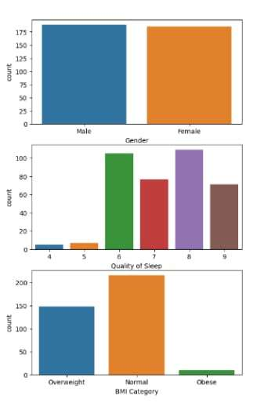

1. Sleep Disorder Detection Test Results in Terms of the Gender, Quality of Sleep & BMI Category in the Datasets.

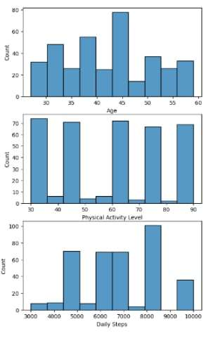

1. Sleep Disorder Detection Test Results in Terms of the Age, Physical Activity Level & Daily Steps Category in the Datasets.

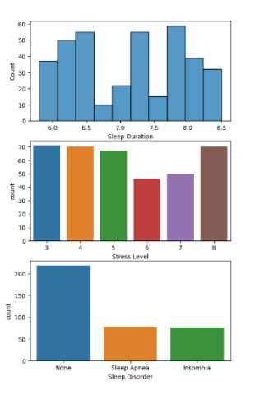

1. Sleep Disorder Detection Test Results Regarding the Sleep Duration, Stress Level & Sleep Disorder Category in the Datasets

In the Top chart Figure 1's displays the number of people by gender, with roughly equal numbers of men in blue color and women in orange color. In the second figure shows quality of sleep how well they slept, with scores between 4 to 9, in this figure 6 through 8 had the highest counts. The last chart of the figure shows the number of people by BMI category. The highest number of people falls into the "Normal" category, followed by "Overweight," and the lowest number falls into the "Obese" group. The distribution of people by age is defined in Figure 2's first histogram. The physical activity degrees determine the central point of the histogram. If we look at the lower histogram, it tells us how many individuals took steps each day, where there are additional peaks at 5000 and 9000 step values besides the highest one of around 7000 steps. Displayed in Figure 3 is an illustration demonstrating the interval of sleep length analyzed between 6.0 and 8.5 hours for amounts represented by figures 40-55. There exists a central part chart that shows stress levels with numbers 3 and 4 as the most frequent values. The bottom chart reveals incidence rates for different types of disorders related to sleep; it demonstrates that majority of individuals exhibit no signs while a reduced proportion presents with insomnia alongside sleep apnea.

This dataset comprehensively details people's sleep habits and related health indicators. It can investigate relationships between sleep problems and other elements such as employment, physical activity, stress levels, and general health markers such as blood pressure and BMI. Choose the cell range containing duplicate values that you wish to eliminate heart rate and blood pressure.

## **Dataset Preprocessing**

We use all of the preprocessing approaches in our project, including replacing missing, null, and duplicate values, identifying outliers, scaling features, encoding categorical data, and oversampling methods.

Missing/null: Although there are no null values in our dataset, we attempt to identify the missing values using the missing/null techniques.

Replace duplicate values: To replace duplicate values, we identify and eliminate the range of duplicate cells.

Outlier Identification: The method of locating data points outside a particular range of percentiles is known as outlier identification. We employed this technique in addition to outlier removal.

Feature scaling: Normalizing a dataset's feature range involves data scaling to determine its value. This is known as feature scaling.

Encoding Categorical Data: One of the most essential preprocessing procedures for machine learning applications is encoding categorical data. We have encoded categorical data, including gender, occupation, blood pressure, BMI category, and sleep disturbance, in our dataset.

Oversampling techniques: The oversampling value is determined by using the smote. The Synthetic Minority oversampling approach is called Smote.

## **Machine Learning Models**

### Random forest: Random forest is an ensemble machine learning model. This model first builds multiple decision tree models from the dataset. Each tree is built upon a random subset of the training data. Then, each decision tree classifier makes a prediction. After that, the final result is taken by either the majority vote or the average of the projections. This model gives accuracy and prevents the model from overfitting.

### Bagging: Bootstrap aggregating, generally called bagging, is utilized in the system to enhance model accuracy by combining more than one model prediction. This includes training every individual version with a unique random subset of statistics acquired through sampling with an alternative method. In the case of regression duties, predictions are generally mixed through averaging because they constitute non-stop values at the same time as the majority vote is taken while managing class obligations.

### KNN model: The KNN model predicts by calculating the distance between the data and the training samples. Euclidean or Manhattan distance matric will measure this distance. This model can train in classification, multiclassification, and regression datasets. It is a lazy method because this model doesn’t work on the dataset during training; it only stores the data.

### SVM model: this model trains and tests a dataset by creating a hyperplane that maximizes the margin width (distance between the decision boundary and training data points closest to the hyperplane). There are two types of margins: complex (avoid misclassifications) and soft (allow some misclassifications for better generality). This model can train linear, nonlinear, and regression problems. This model works excellently for small- and medium-sized datasets.

### Decision Tree: Regression and classification tasks are two common uses for decision trees as machine learning models. The process creates a decision tree-like structure by dividing the data into subsets according to feature values. Every leaf node in the tree represents a class label, each internal node represents a test on a feature, and each branch reflects the test's result. Decision trees can handle category and numerical data and are simple to understand. Discrete valued target function approximation uses the decision tree learning technique. Each node is selected according to these coefficients, expressed as entropy or Gini, which are used to calculate information gain.

### Logistic Regression: Logistic regression operates a statistical method for binary classification, locating the tasks and predicting the value of the input given where it belongs to two categories. The logistic function model has a relationship between binary and independent variables. 0 and 1 are the primary output values of this function. Also, it's called the sigmoid function. In this model uses the best-fitting parameters that reduce the error between predicted and actual outcomes.

### AdaBoost Model: Adaptive Boosting (in short, AdaBoost) is a boosting technique used as an ensemble method in ML to enhance prediction. It Works by weighting incorrect classified instances more heavily so that the subsequent weak learners focus more on complex cases. AdaBoost is exceptionally functional when the data is noisy or has many inapt features.

### GradBoost Model: Gradient Boosting (in short, GradBoost) optimizes the performance through gradient descent and builds an ensemble of weak prediction models (commonly decision tree) to enhance prediction accuracy by iteratively minimizing the errors.

### XGBoost Model: An advanced implementation of GradBoosting that optimizes performance and speed using parallel processing, regularization techniques, and tree pruning. It works remarkably in handling large datasets and provides robust predictive accuracy for classification and regression.

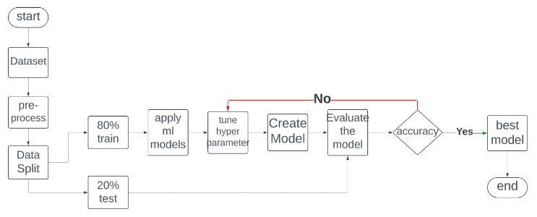

1. Working Sequences of the Proposed Sleep Disorder Detection System.

This flowchart represents the complete workflow of our project. At first, we chose a dataset and then processed the dataset. We split the dataset as 80% split and 20% test. Then, we apply different ml models and tuned hyperparameters. Then, we train the 80% data and test the model with the remaining 20% data. If we get the best model, we end the model training. If we don’t, we will tune the model again to train. We follow these steps to create the best model.

# **Results and Discussion**

We first prepared each model in our dataset using the default hyperparameters, and then we fine-tuned the hyperparameters to calculate the four measurements—precision, exactness, review, and f1 score.

TABLE II. HYPERPARAMETER OPTIMIZATION RESULTS FOR VARIOUS MACHINE LEARNING MODELS

|  |  |  |
| --- | --- | --- |
| Model | Hyperparameter Value Range | Optimized value |
| Decision tree | criterion: [Gini, entropy], max_depth: np.arange(3, 9) | criterion: gini, max_depth:6 |
| KNN | n_neighbors: [1, 2, 3, 4, 5, 6], weights: [uniform, distance], metric: ['manhattan',’euclidian] | n_neighbors=3, weights='distance', metric='manhattan' |
| Random forest | n_estimators: [200,500],  max_features: [auto, sqrt, log2],  max_depth: [4,5,6,7,8],  criterion: [Gini, entropy] | n_estimators=200, max_features='sqrt', max_depth=4, criterion='gini' |
| Logistic regression | C: [0.15, 0.88, 1.60, 2.32, 3.05, 3.77, 4.50, 5.22, 5.95, 6.67, 7.40, 8.12, 8.85, 9.57, 10.30, 11.02, 11.75, 12.47, 13.20, 13.92],  penalty: ['l2'],  solver: ['lbfgs', 'liblinear'] | C:0.1,  Penalty:12 |
| SVM | C: [0.1, 1, 10, 100, 1000],  gamma: [scale, auto], kernel: [linear, RBF], decision_function_shape:[‘ovo’, ‘ovr’] | C=1.0, gamma='scale', kernel='linear', decision_function_shape='ovr' |
| AdaBoost | base_estimator__criterion: [gini, entropy],  base_estimator__splitter: [best, random],  n_estimators: [1, 50] | base_estimatorcriterion: entropy, base_estimatorsplitter: random, n_estimators: 28 |
| Gradient Boosting | max_depth: range (2, 10, 1) , n_estimators: range (60, 220, 40) learning_rate: [0.1, 0.01, 0.05] | learning_rate: 0.01, max_depth: 2, n_estimators: 140 |
| XGBoost | max_depth: range (2, 10, 1),  n_estimators: range (60, 220, 40)  learning_rate: [0.1, 0.01, 0.05] | learning_rate: 0.1, max_depth: 2, n_estimators: 60 |
| Bagging | base_estimator=base_estimator,  n_estimators=int,  max_samples=int to float,  max_features=int to float | base_estimator=DecisionTreeClassifier,  n_estimators=10,  max_samples=0.5,  max_features=0.5 |

The table shows all the hyperparameter ranges and optimized hyperparameters we used to train all the models. Each model has their hyperparameters and those hyperparameters have different ranges. In the decision tree we can use both Gini or entropy but using the Gini model, we get the best result. Another example is in the KNN model, to measure the distance with we can use both Manhattan and Euclidean distance but Manhattan gives the best result. As a result, for the decision tree, Gini is the optimized hyperparameter, and for the KNN model, Manhattan is the optimized hyperparameter. Besides these table II describes all the hyperparameter value ranges and optimized values.

TABLE III. PERFORMANCE METRICS OF MACHINE LEARNING MODELS WITH DEFAULT HYPERPARAMETERS

|  |  |  |  |  |
| --- | --- | --- | --- | --- |
| Model | Accuracy | Precision | Recall | F1-score |
| decision tree | 89.39% | .8961 | .8939 | .8926 |
| knn | 90.15% | .9028 | .9015 | .9000 |
| random forest | 89.39% | .8938 | .8939 | .8939 |
| **logistic regression** | **91.67%** | **.9174** | **.9167** | **.9164** |
| svm | 87.88% | .8828 | .8788 | .8797 |
| adaboost | 68% | 0.62 | 0.65 | 0.63 |
| xgboost | 89.33% | 0.85 | 0.83 | 0.84 |
| gradboost | 89% | 0.85 | 0.83 | 0.84 |
| bagging | 90.2% | .901 | .902 | .901 |

The table describes the measurement of the four performance metrics with default parameters for every model. We got the best accuracy for logistic regression, which is 91.67% with strong precision, recall, and f1 score, and the lowest for Adaboost model which is 68%.

TABLE IV. PERFORMANCE METRICS OF MACHINE LEARNING MODELS WITH OPTIMIZED HYPERPARAMETERS

|  |  |  |  |  |
| --- | --- | --- | --- | --- |
| Model | Accuracy | Precision | Recall | F1-score |
| decision tree | 91.67% | .9171 | .9167 | .9156 |
| knn | 90.15% | .9038 | .9015 | .9008 |
| random forest | 92.42% | .9257 | .9242 | .9232 |
| logistic regression | 92.42% | .9244 | .9142 | .9164 |
| svm | 90.15% | .9012 | .9015 | .9007 |
| adaboost | 90.2% | .904 | .902 | .901 |
| xgboost | 90.9% | .910 | .909 | .907 |
| gradboost | 89.4% | .893 | .894 | .893 |
| bagging | 92.4% | .924 | .924 | .924 |

We calculated the same four metrics with tuned hyperparameters for every model. We got the best score for logistic regression and bagging, 92.42%. Bagging has the best precision, recall, and f1 score. Gradboost has the lowest accuracy, which is 89.4%. After tuning the hyperparameters, the accuracy for all the models got better. Now, all the models have accuracy higher than 90% except for Gradboost, and as expected the other metrics also got better.

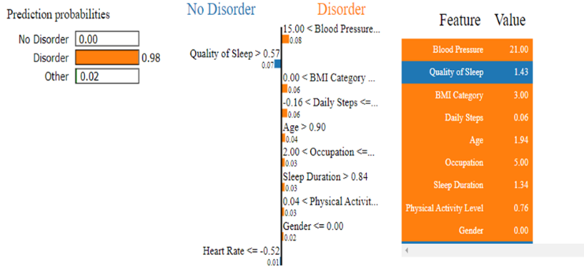

Fig. 5. Machine Learning Model Prediction Interpretation by LIME Explainable AI Library.

This is a picture of a figure that demonstrates Machine learning model prediction interpretation by the LIME explainable AI library. This figure is divided into three parts. The left side shows prediction probabilities (no disorder, disorder, other), the right part shows the feature list and the exact values, and the middle section highlights the key features. The quality of sleep features is colored blue, which influences the prediction towards others, and all the other features point toward disorder. Blood pressure (21.00), BMI (3.00), and quality of sleep (1.43) are the most influencing features in predicting the result.

TABLE V. COMPARISON OF PERFORMANCE METRICS WITH REFERENCE STUDIES

|  |  |  |  |
| --- | --- | --- | --- |
| Ref. | Model | Accuracy | Other metrics |
| [1] | Gradient Boosting | 93.51% | none |
| [2] | ANN | 92.92% | Precision= .92  Recall= .93, f1= .91 |
| [3] | XGBoost | 87% | none |
| [4] | CNN Classifier | 94.34% | F1= .92 |
| [5] | Decision tree | 93% | Precision= .90,  recall= .92, F1= .91 |
| This work | logistic regression, random forest and bagging | 92.42% | Precision= .924  Recall= .924, f1= .924 (for bagging) |

# In this table, we compare the metrics of our model with different works already done before. Among these papers, the ANN model got the best accuracy, which is 94.34%, but this is a deep learning model. After that decision tree and Gradboost got the best accuracy around 93%. In our work, we got the highest accuracy with the bagging and logistic regression model, which is 92.42%. Between these papers, the XGboost model got the worst accuracy (87%). After training our model, we also got the worst accuracy with the XGboost model at around 89%.

# Conclusions

##### Sleep disorders are crucial for humans proper functioning. If we can detect it early and accurately, it will give us time to recover. Sleep disorder detection using machine learning projects has the potential to predict and analyze sleep disorders. For modernizing the sleep diagnostic procedure and approaching appropriate treatment plans, our model will be helpful to medical professionals as we get the highest accuracy in the bagging model. So, this project provides a promising solution for sleep disorder detection with advanced processing and integration into clinical habitats. As for future work we will use advanced data like health and biometric data and advance deep learning techniques. We can also use polysomnography recordings to enhance predictive performances.

##### References

1. T. Soni, D. Gupta and M. Uppal, "Enhancing Accuracy of Sleep Disorder with Logistic Regression Model," 2023 IEEE 2nd International Conference on Industrial Electronics: Developments & Applications (ICIDeA), Imphal, India, 2023, pp. 292-295T.S. Alshammari, “Applying Machine Learning Algorithms for the Classification of Sleep Disorders”, IEEE Access, vol. 12, pp. 36110 – 36121, 2024.
2. T.S. Alshammari, “Applying Machine Learning Algorithms for the Classification of Sleep Disorders”, IEEE Access, vol. 12, pp. 36110 – 36121, 2024.
3. P. Payne, V. Singh, M. K. Gourisaria, S. S. Patra and H. Das, "Insomnia, Sleep Apnea, Serenity: Unveiling Sleep Disorders with Machine Learning," International Conference on Intelligent Data Communication Technologies and Internet of Things, 2024, pp. 1603-1609.
4. Y. Cheng, M. Lech, and R. H. Wilkinson, "Simultaneous Sleep Stage and Sleep Disorder Detection from Multimodal Sensors Using Deep Learning," Sensors, vol. 23, no. 7, p. 3468, 2023.
5. P. K. Yadav, U. K. Singh, J. J. A. Kovilpiaali and R. Tamilarasi, "Sleep Disorder Detection using Machine Learning Method," International Conference on Automation, pp. 1530-1532, 2023.
6. F.M. Yunus, S. khan, T. Akhter, F.T. Jhohura, A. Islam, M. Rahman, "How many hours do people sleep in Bangladesh? A country‐representative survey." Journal of sleep research 25, no. 3, pp. 365-376, 2016.
7. Cleveland Clinic. "Sleep Disorders." Cleveland Clinic. Accessed:May11,2024.[Online].Available: <https://my.clevelandclinic.org/health/diseases/11429-sleep-disorders>.
8. SingleCare. "Sleep Statistics." SingleCare. Accessed: May 11, 2024.[Online].Available: <https://www.singlecare.com/blog/news/sleep-statistics/>.
9. National Sleep Foundation. "Sleep Facts & Statistics." National Sleep Foundation. Accessed: May 11, 2024. [Online]. Available:<https://www.sleepfoundation.org/how-sleep-works/sleep-facts-statistics>.
10. Institute of Medicine (US) Committee on Sleep Medicine and Research, "Sleep Disorders and Sleep Deprivation: An Unmet Public Health Problem," National Academies Press (US), 2006. [Online]. Available: https://pubmed.ncbi.nlm.nih.gov/20669438/. Accessed: Jun. 10, 2024.